**Team Name**: We Can Do It

**Date of Submission:** 10/03/2021

**Meeting Date & Time:** 10/02/2021 @ 6:00PM

**Meeting Location:** Zoom

**Meeting Duration:** 1 hour and 2 minutes

| **Team Members** | **X = Present** | **Notes** |
| --- | --- | --- |
| Dhari Alenezi | X |  |
| Abdulrahman Alharbi | X |  |
| Elina Do | X |  |
| Andrew Nguyen | X |  |

**Progress:**

**Team accomplishments for the week:**

This week, we discussed what we have accomplished such as finalizing the database design, designing the mobile screens, and how the application and web page will interact with the backend side. Also, we wrote a to-do list of things that we plan to accomplish the following week which includes adding more Cases inside the database, and developing the QR logic. In addition, this week Dhari & Elina developed a Database Seeder, which will help us to control the database with the command line, and it will help us to test our database inside the mobile application.

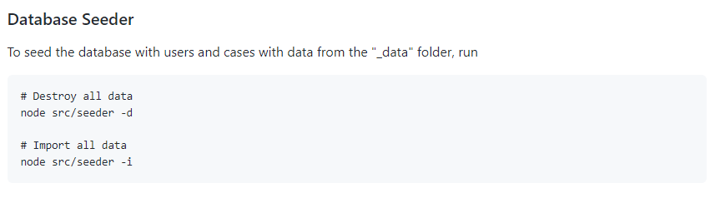

**Screenshots ( Dark mode ):**

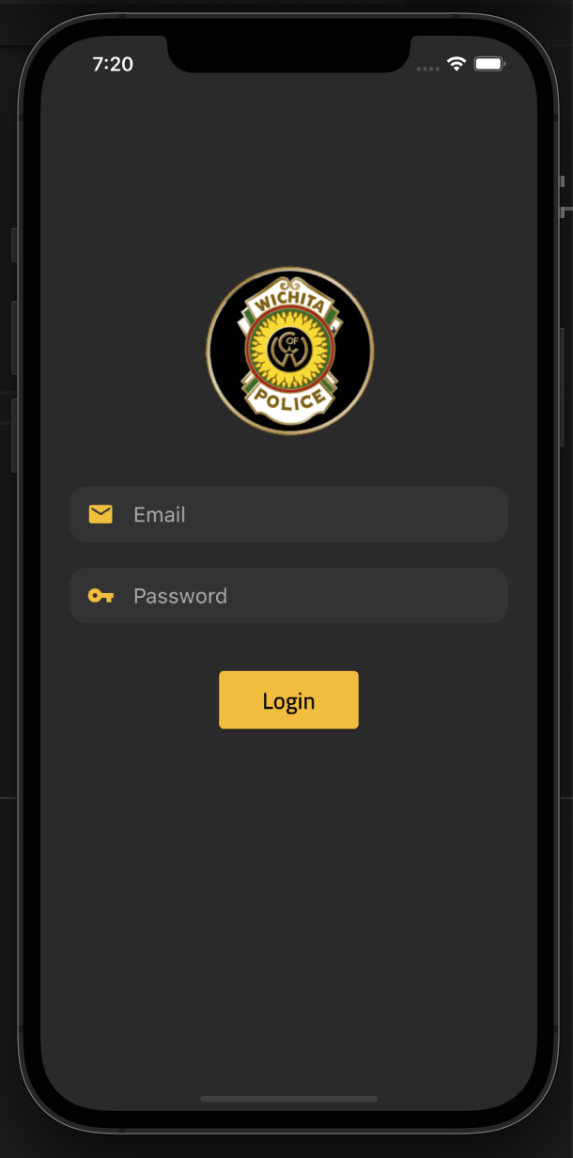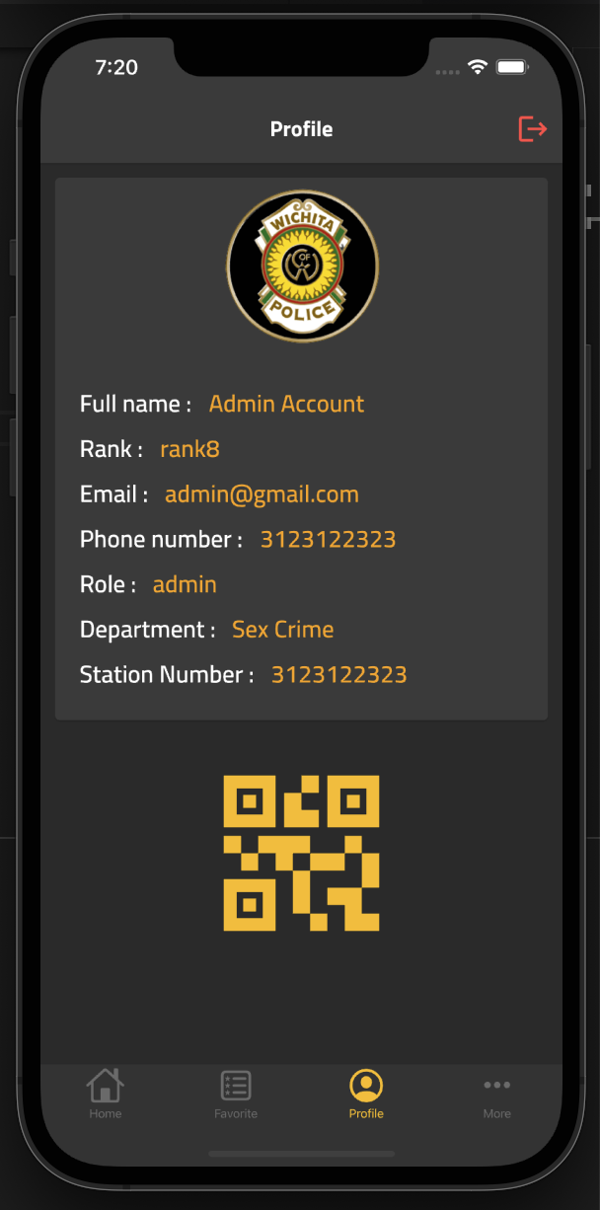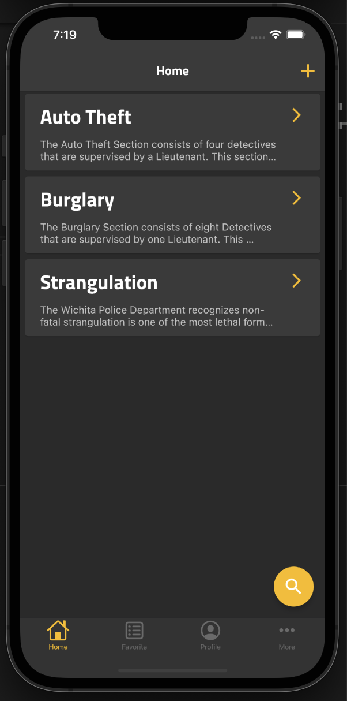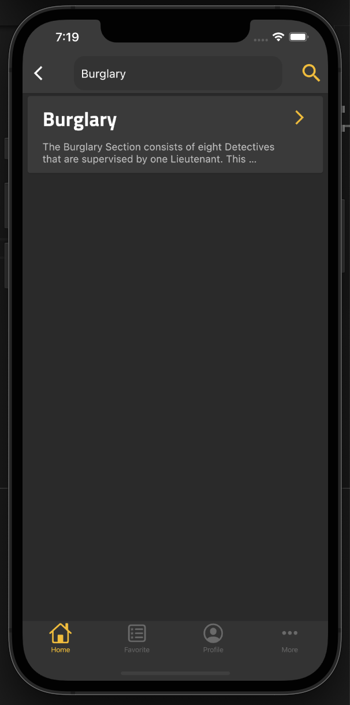

**Screenshots ( Light mode ):**

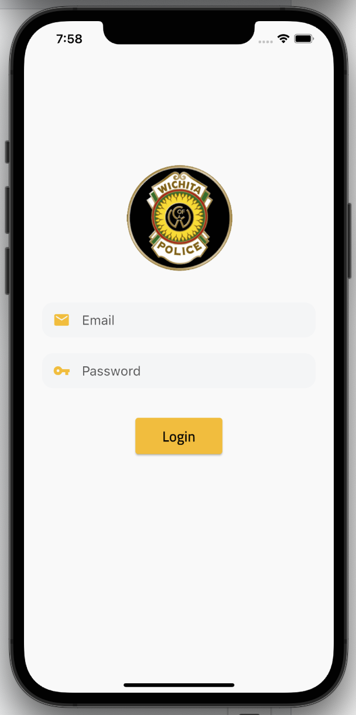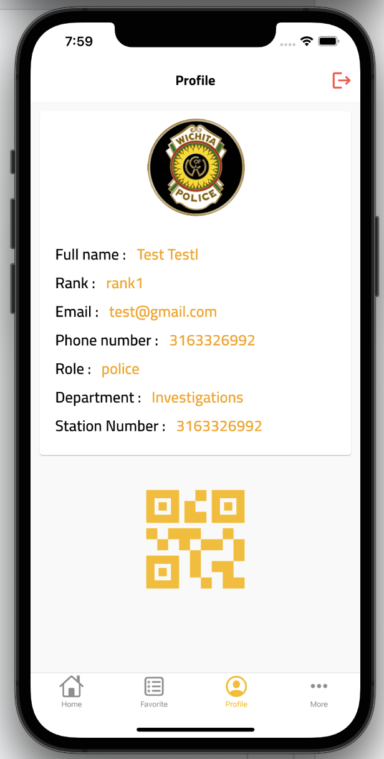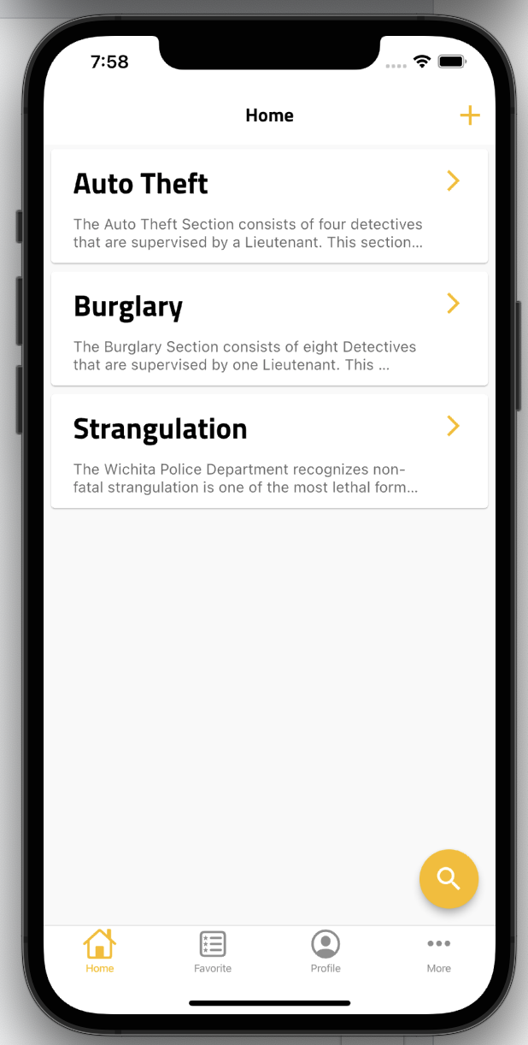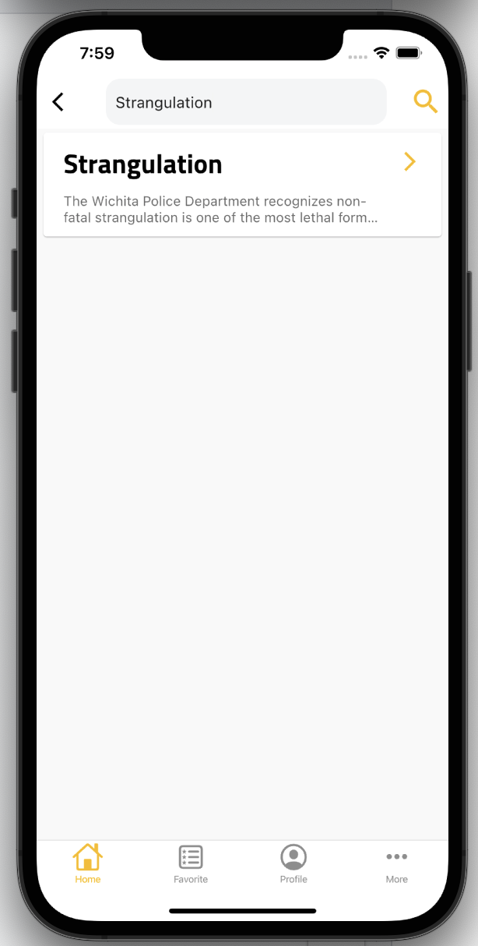

**Individual contributions:**

**Dhari Alenezi:** This week, I finished developing the search logic, the home screen, and the profile screen. I fixed some bugs inside the authentication logic. Also, I developed with Elina the Database Seeder which will help us to add & delete the database with just one command line.

**Abdulrahman Alharbi:** Worked on designing the app screens layout. Worked on designing the buttons for the app. Designing the loaders, and support shimmer loader for both dark & light mode.

**Elina Do:** Started designing a diagram for the schema and began to add sample cases from the WPD to the database for testing. Worked with Dhari to develop the database seeder that will make it raiders for us to add and delete the database.

**Andrew Nguyen:** Started working with Dhari to pull in back-end HTTP endpoint data on the front-end. Grabbing the data to display it on the webapp in correct format and places.

**Project Tracking:**

| **Team Member** | **Assignment** | **Due Date** | **% Complete** |
| --- | --- | --- | --- |
| Dhari Alenezi | Developing the QR logic & Case screen | 10/09/2021 | 20% |
| Dhari Alenezi | Developing the faviorte screen | 10/14/2021 | 10% |
| Abdulrahman Alharbi | Working on the front end of the app | 10/18/2021 | 20% |
| Elina Do | Complete first draft of base code for database in MongoDB | 09/17/2021 | 50% |
| Andrew Nguyen | Create static web prototype for WPD to test and give feedback on | 09/19/2021 | 100% |
| Andrew Nguyen | Link web app with back end to display information | 10/06/2021 | 30% |
| Andrew Nguyen | Fix some minor issues with static web prototype | 09/30/2021 | 80% |

**Plan:**

| **Assignment** | **Due Date** |
| --- | --- |
| Finish developing and structuring the HTTP endpoints | 10/9/2021 |
| Developing the QR logic | 10/09/2021 |
| Developing the faviorte screen | 10/14/2021 |
| Link the HTTP endpoints with the mobile application | 10/17/2021 |
| Support web application | 10/20/2021 |
| Try & test NFC technology (Near-field communication) | 10/30/2021 |
| Developing the cache feature for the mobile app | 10/31/2021 |
| Testing both the frontend & backend sides | 11/7/2021 |
| Web App final review | 11/14/2021 |
| Web App finalized and ready for presentation | 11/28/2021 |
|  |  |
|  |  |
|  |  |
|  |  |
|  |  |

**Issues:**

Include the schedule for the next meeting:

Meeting Date & Time: 10/09/2021 @ 6:00PM

Meeting Location: **Zoom**